Session 4
Working with Translations

Translation: Taking God’s message found on the pages of the Bible originally written in Hebrew, Aramaic, and Greek, and putting it into your own language.
the nature of language:
- Translation always involves interpretation
- No two languages have the same vocabulary and grammar
- Words have different meanings, depending on their usage and context
- Strategies:
Learn the biblical languages, use translation tools, compare modern translations

- The Biblical Languages
  - Hebrew
Northwest Semitic language
Biblia Hebraica Stuttgartensia based on Leningrad Codex of 1008 AD
- There have been four main periods of Hebrew:
            - Biblical Hebrew 1300-200 BC
            - Mishnaic or Rabbinical Hebrew 200 BC - AD 600
            - Medieval Hebrew AD 800-1800
            - Modern Hebrew 1948- (becoming a standardized language)
- Script
- Earliest called Paleo-Hebrew
- Square script from 200 BC to today
- Vowel points added by the Masoretes around AD 500 to aid in pronunciation.
- Basic Characteristics
- Based on roots of usually three consonants. Vowel points, suffixes and prefixes are added to the roots to give different meanings.
- The normal word order is verb, subject, and object.
- The verb is central and primary. Two basic tenses:
- Perfect - signifying completed action; point of view of subject (past)
- Imperfect - showing action not completed (future).

  - Aramaic
Northwest Semitic language similar to Hebrew
- Official international language after Assyrians gained power in the 8th century BC.
- Genesis 31:47; one verse in Jeremiah 10:11; Ezra 4:8-6:18 and 7:12-26; and Daniel 2:4b-7:28.
- At least five Aramaic words appear in the New Testament: Cephas, Tabitha, Maranatha, ephphatha, and talitha cumi.
- The native language of Jesus and disciples

  - Greek
Indo-European language
New Testament
  - History of the Greek Language
- Early Greek (2000-900 BC)
- Classical Greek (900-330 BC)
- Koine Greek (330 BC - AD 330)
- Byzantine Greek (AD 330-1453)
- Modern Greek (AD 1453 -present)
- Characteristics of Greek
      - highly “inflectional” with basic root words modified by prefixes, infixes, and suffixes
      - Koine adapted foreign words
      - Rich resource for theological expression
      - Many New Testament words are based on the Septuagint.

- A Short History of Bible Translation
- The First Translating
- Nehemiah 8:8
- Done in local synagogues known as targums
- English translation of the targums called The Aramaic Bible (http://tyndalearchive.com/scriptures/abt.htm).

- Septuagint (LXX)
- First written translation of the Bible
- Provided theological vocabulary
- The Bible for early Christians
- Provided the Old Testament in main international language
- Included the Apocrypha
- The Old Testament for Christians
- Raised question about the Apocrypha

- Other Ancient Versions
              - Greek version of Aquila (2nd cent. AD)
              - Greek version of Theodotion (2nd cent.)
              - Greek version of Symmachus (late 2nd cent.)
              - Syriac Peshitta (AD 180)
              - Various Latin translations (until 4th cent.)
              - Coptic (4th cent.) then Gothic, Armenian, Georgian, and Ethiopic
Each of these translations arose to serve the missionary needs of the church.
              - Jerome’s Latin Vulgate (late 4th cent.)

- Modern Translations
- Languages constantly change
Biblegateway: http://www.biblegateway.com).
- Philosophies of Translation:
Formal Equivalence (Literal) Functional Equivalence (Dynamic)
Focuses on words and grammar Focuses on meaning
Privileges the original language Privileges the receptor language
Most attentive to the original context Most attentive to the contemporary context
Retains ambiguities Removes ambiguities
Tries to minimize interpretive bias Accepts the reality of interpretive bias
May try to replicate author’s style May try to create a contemporary style
Paraphrase: restates key ideas using many words, goes beyond functional

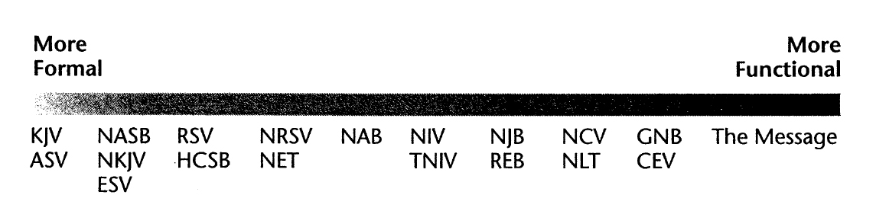
- Translation Committees
Translation always involves some degree of interpretation
Committees are more ecumenical and inclusive
They still may have biases

Summary of Big Ideas
- Translation always involves interpretation about what words to use.
- The three languages of the Bible are Hebrew (OT), Aramaic (only small parts), and Greek (NT).
- Two important ancient translations of the Bible were the Septuagint (Greek) and Vulgate (Latin).
- The two primary approaches to Bible translation are called the formal (literal) and functional (thought for thought).
- We should be aware of the theological biases of the translators of the Bible.

